Telephone User Guide

Version 1.0

Synopsis: This document explains how to use a telephone to an alien visiting from Mars.
This document was a Credit Suisse, 45-minute writing test for a job that I won. I obtained
all illustrations from internet image searches. The test was how well I could process and
present information.

Authors: Brian Van Watson
Contributors: Telephone Company and Alexander Graham Bell

Document Version: 1.0
Date:

Status: Draft

Table of Contents

Table of Contents 2
What is a telephone? 3
How a telephone works 3
What you need to use a telephone 4
The key components of a telephone 4
Making a telephone call 5
Answering a telephone call 5
Troubleshooting basic problems 6
Getting help 6

What is a telephone?
The telephone (or phone) is a communications device that allows two or more people to communicate without being in the same location. The telephone is supported by something called a telephone network (Wires and accessories), composed of many fiber optic lines (wires) and computer systems (tools that allow people to send and voice data). Using a telephone to speak with another person is often more effective and faster than sending a letter. With a phone, you make what is known as telephone “calls” to other people.

How a telephone works
Let’s suppose you want to speak to a friend who lives a considerable distance from you. The diagram below illustrates what happens and the table below explains it. Here’s what happens:
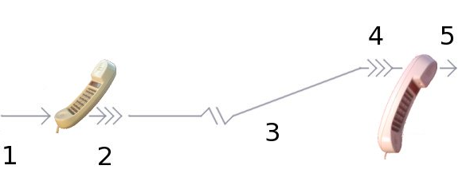
Stage | Description
1. | The sound of your voice causes vibrations in the air. These vibrations carry the sounds from your voice into the telephone.
2. | A microphone located on the telephone converts your sounds into electrical currents.
3. | The electrical currents move from the phone, via devices called exchanges at the telephone company, to the telephone of the person who you are trying to contact.
4. | The earpiece loudspeaker on your friend's telephone converts the incoming electrical currents back to sound, so he or she can hear you.
5. | The sound travels out from the earpiece on your friend’s telephone into his or her ear. Then, he or she can hear you speaking.

What you need to use a telephone
To use your telephone, you need the following:

- AC electricity
- Telephone lines and wall jacks
- An account with the telephone company
- A telephone handset.

The key components of a telephone
The following table lists and describes the essential components of a telephone:

Component | Description and Function
Keypad | Alphanumeric numbers and letters located on the handset. Allows you to dial the phone number of the person with whom you want to speak.
Microphone | Small opening on the button of the handset. This button allows you to speak into the phone.
Speakerphone | Allows you to speak on the telephone without having to hold the handset.
Mute Button | Allows you to temporarily turn off the sound of the telephone whereby you can hear the other party speaking, but they cannot understand your voice.

The following illustrates essential telephone components:

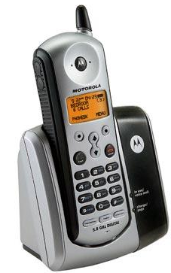
Earphone
Display Panel
Mute Button
Keypad
Handrest
Speaker Phone Button
Microphone
Hold Button
Handset

Making a telephone call
To make or place a telephone call to another person, you must complete the following tasks (Please refer to the illustration and table above for further information regarding telephone components.):

Step | Action
1. | Lift the handset off of the handrest, and place the handset to your ear.  Result: You will hear a dial tone sound.  What this means: This means you are ready to make your call.
2. | Upon hearing a dial tone, use the keypad on the handset to enter the phone number of the person you want to call. Do this by pressing each number on the keypad that corresponds to the other party’s telephone number.  Result: After entering the phone number of the person you are trying to contact, you will hear ringtones.  What this means: This means the other person’s telephone is ringing, alerting him or her to answer.
3. | Speak to the person you are trying to reach when he or she answers.  - You can also use the speakerphone and talk to your party without holding the handset, by pressing the Speakerphone button on the handset.  - Additionally, you can prevent the other person from hearing you, by putting the caller on mute. To do this, press the Mute button on the handset.  - You can also place the call on hold, by pressing the Hold button located on the handset. You do this when you need to answer another call or do something else, and you do not want to end the call with the person with whom you are speaking.
4. | Place the phone on the handrest when you have finished your conversation.  Result: The telephone is considered to be "hung up."  What this means: To speak to your friend again, you must repeat steps 1 through 4.

Answering a telephone call
To answer a telephone call, following these steps:

Step | Action
1. | Upon hearing the telephone make a ringing sound, pick the handset up off of the hand rest and place the handset to your ear.
2. | Say “hello” into the microphone located on the bottom of the handset.  Result: You will hear the other person’s in response.  What this means: You can begin your conversation.

Troubleshooting basic problems

If you have this problem: | do this:
No dial tone | Ensure that the phone is connected to the wall jack and redial the telephone number of the person to which you want to speak.
Phone keys are stuck | Dust off the keypad to remove any dust or dirt particles.
Static on phone line | When speaking on the phone and hearing static (other noise on the line) move to a different part of the house or hang up the phone and redial the phone number of the person you are trying to reach.

Getting help
If you are still having difficulties making or receiving calls, request help by sending a letter to the telephone company or to the company that made your particular telephone.

